**STUDENT NAME:  *(please replace with your name)***

**Lab3A Output**

(private/public Ips, availability zone)

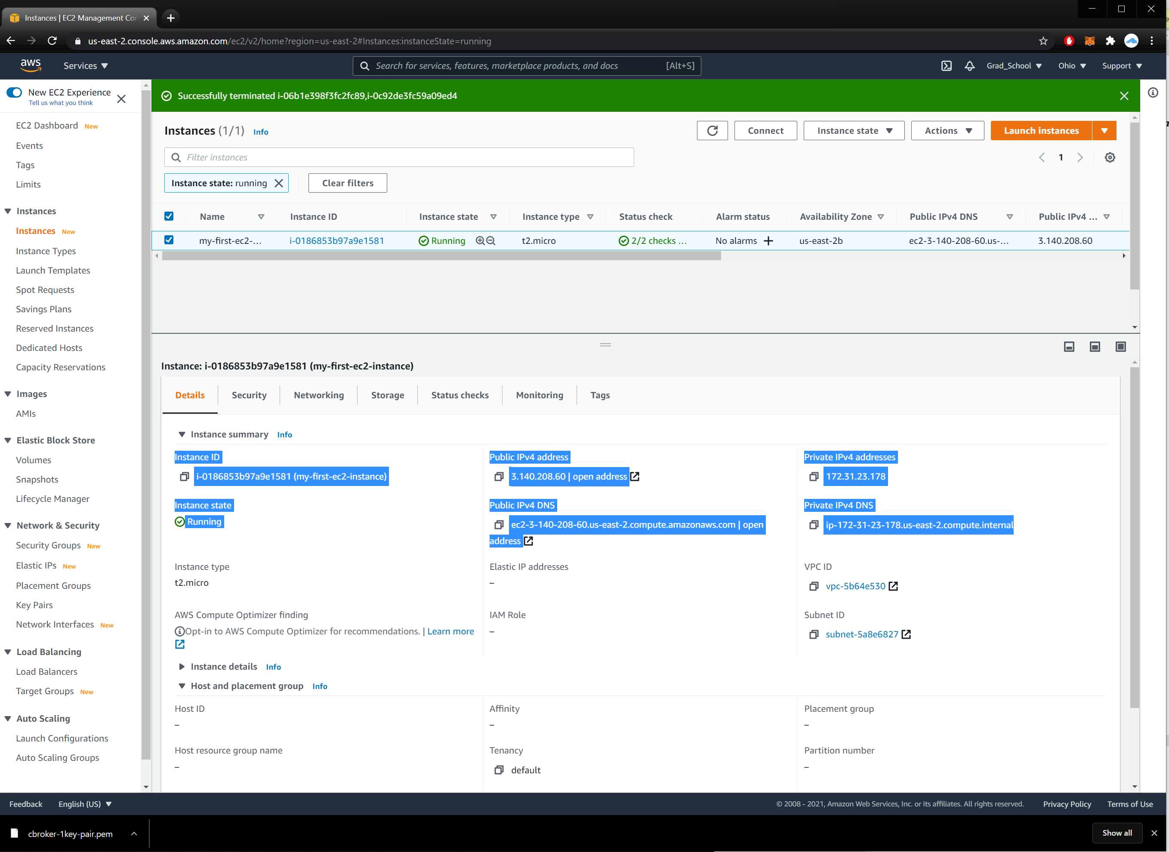

**(keypair)**

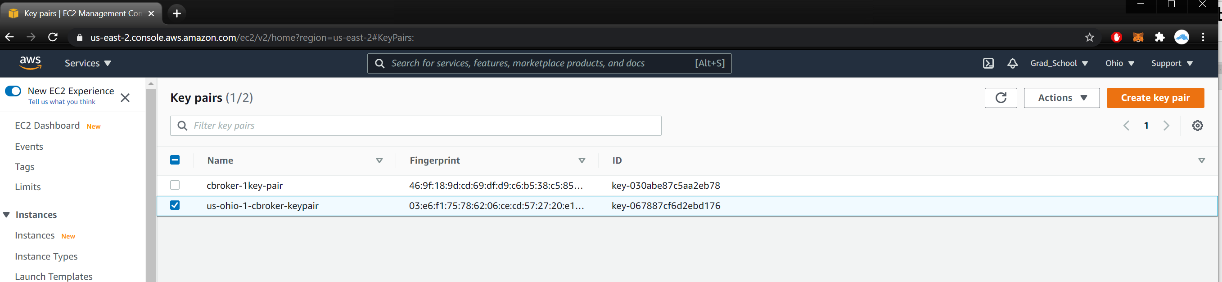

(security group)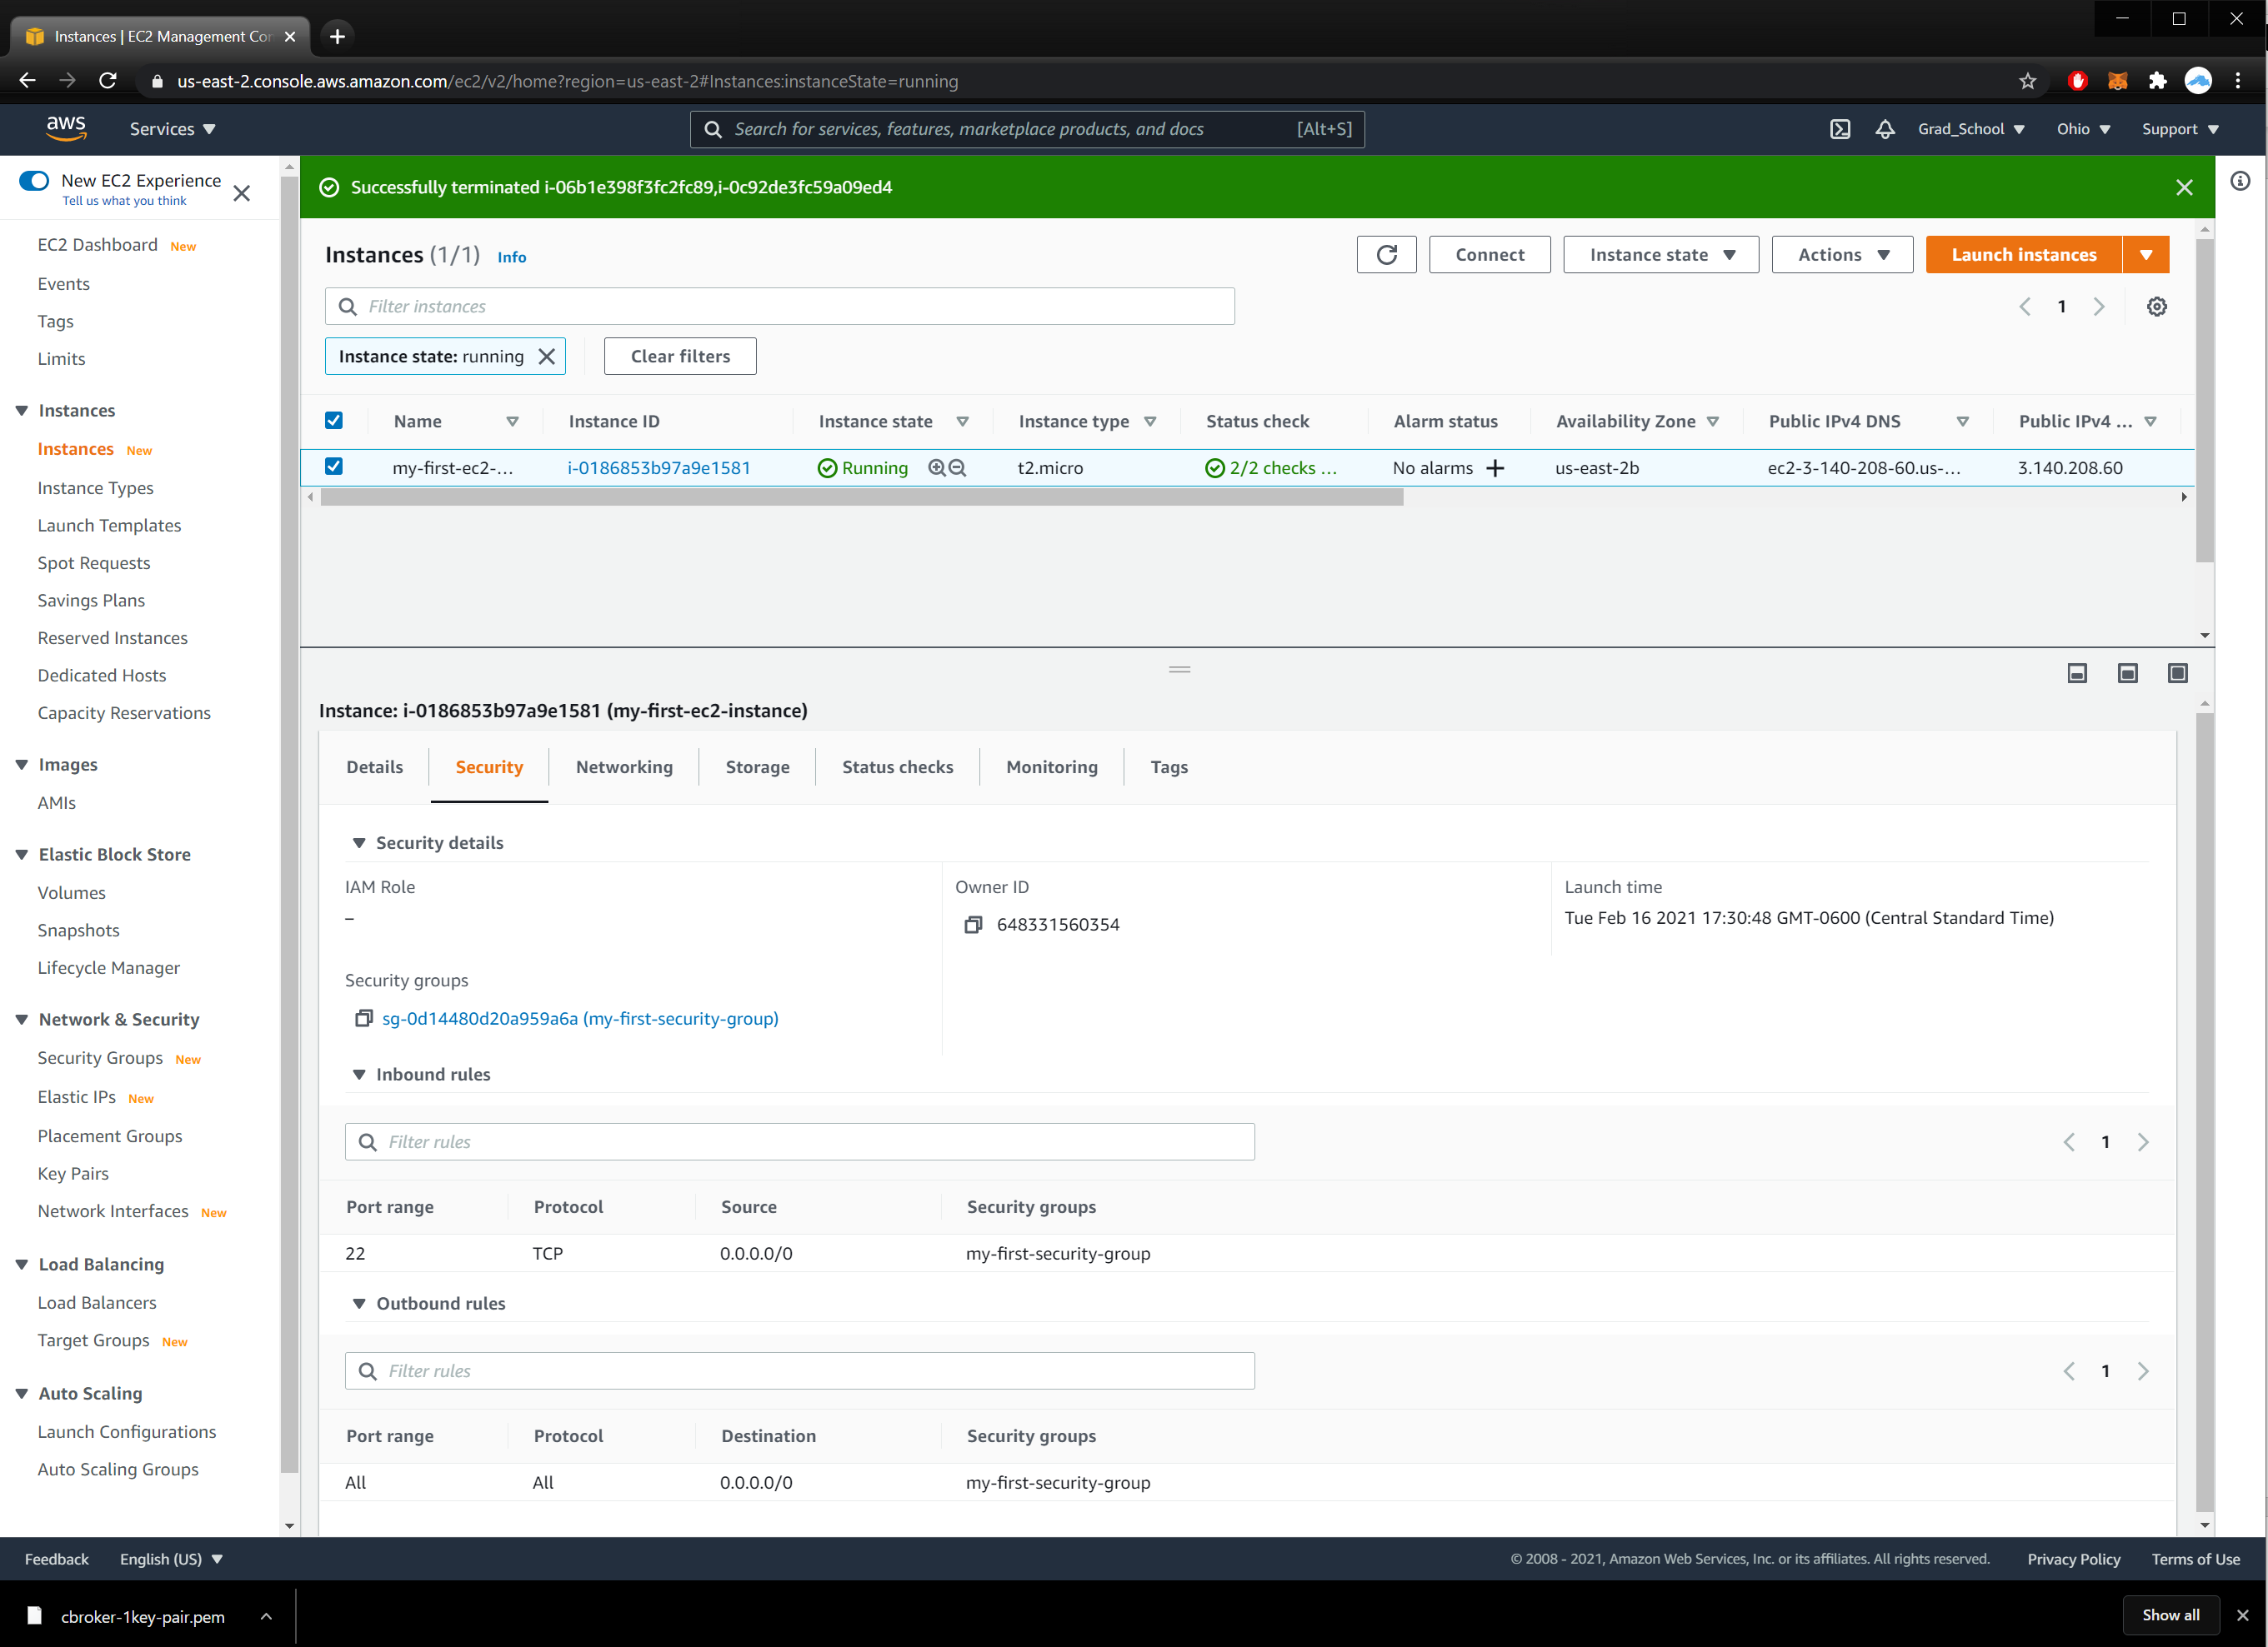

**Lab3B Output**

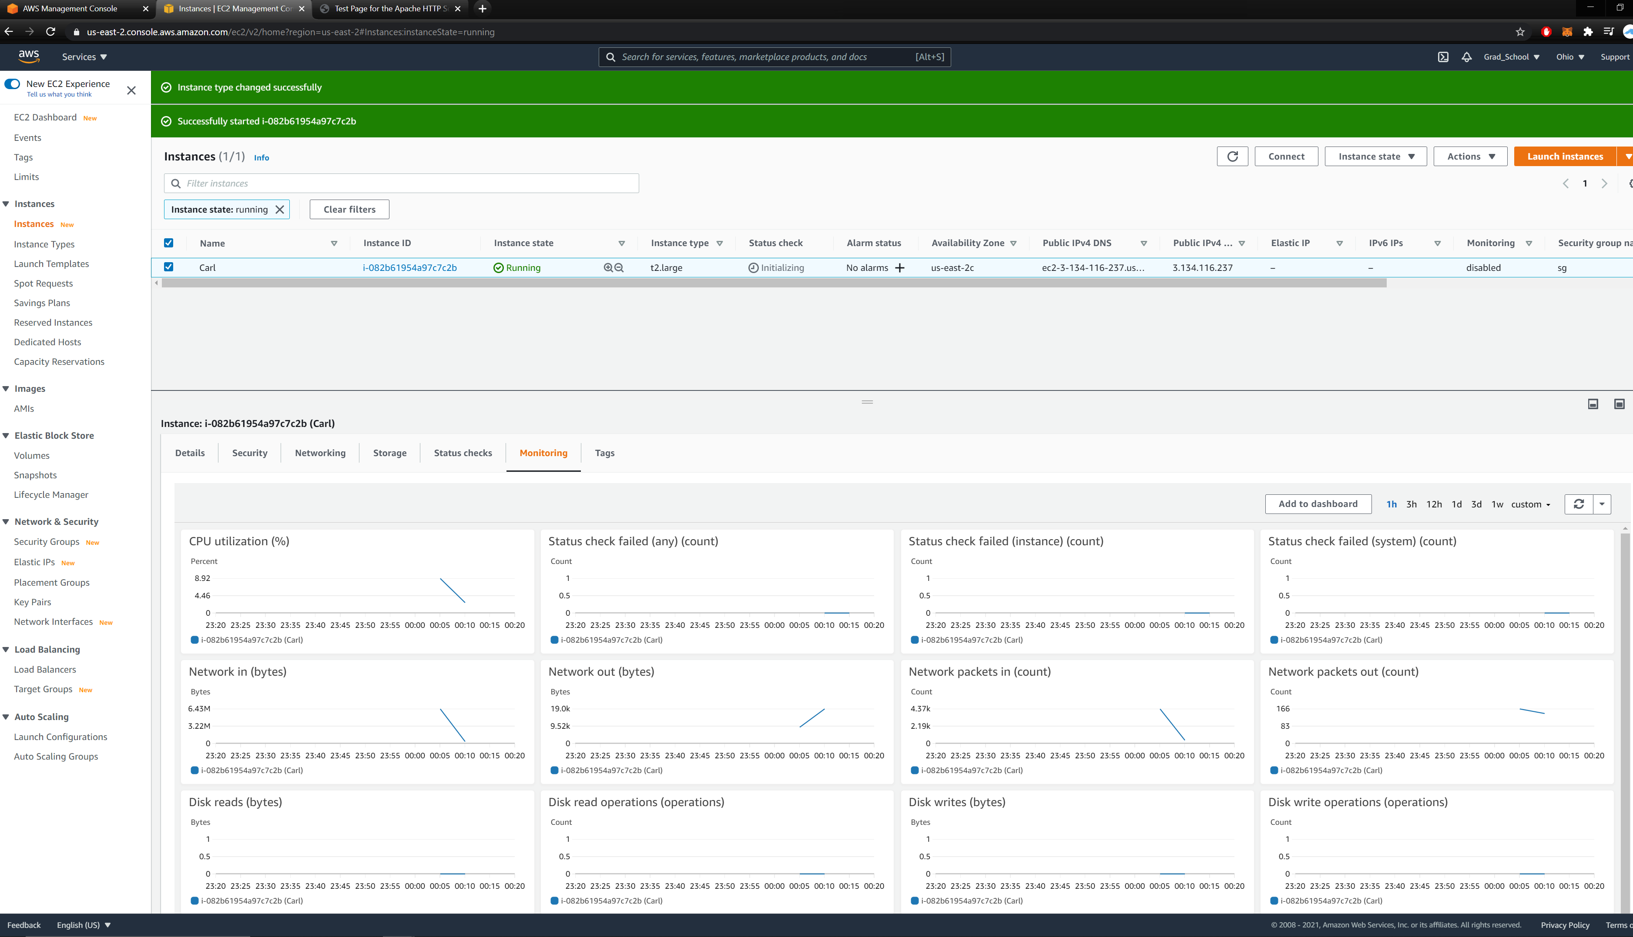

**Lab3C Output**

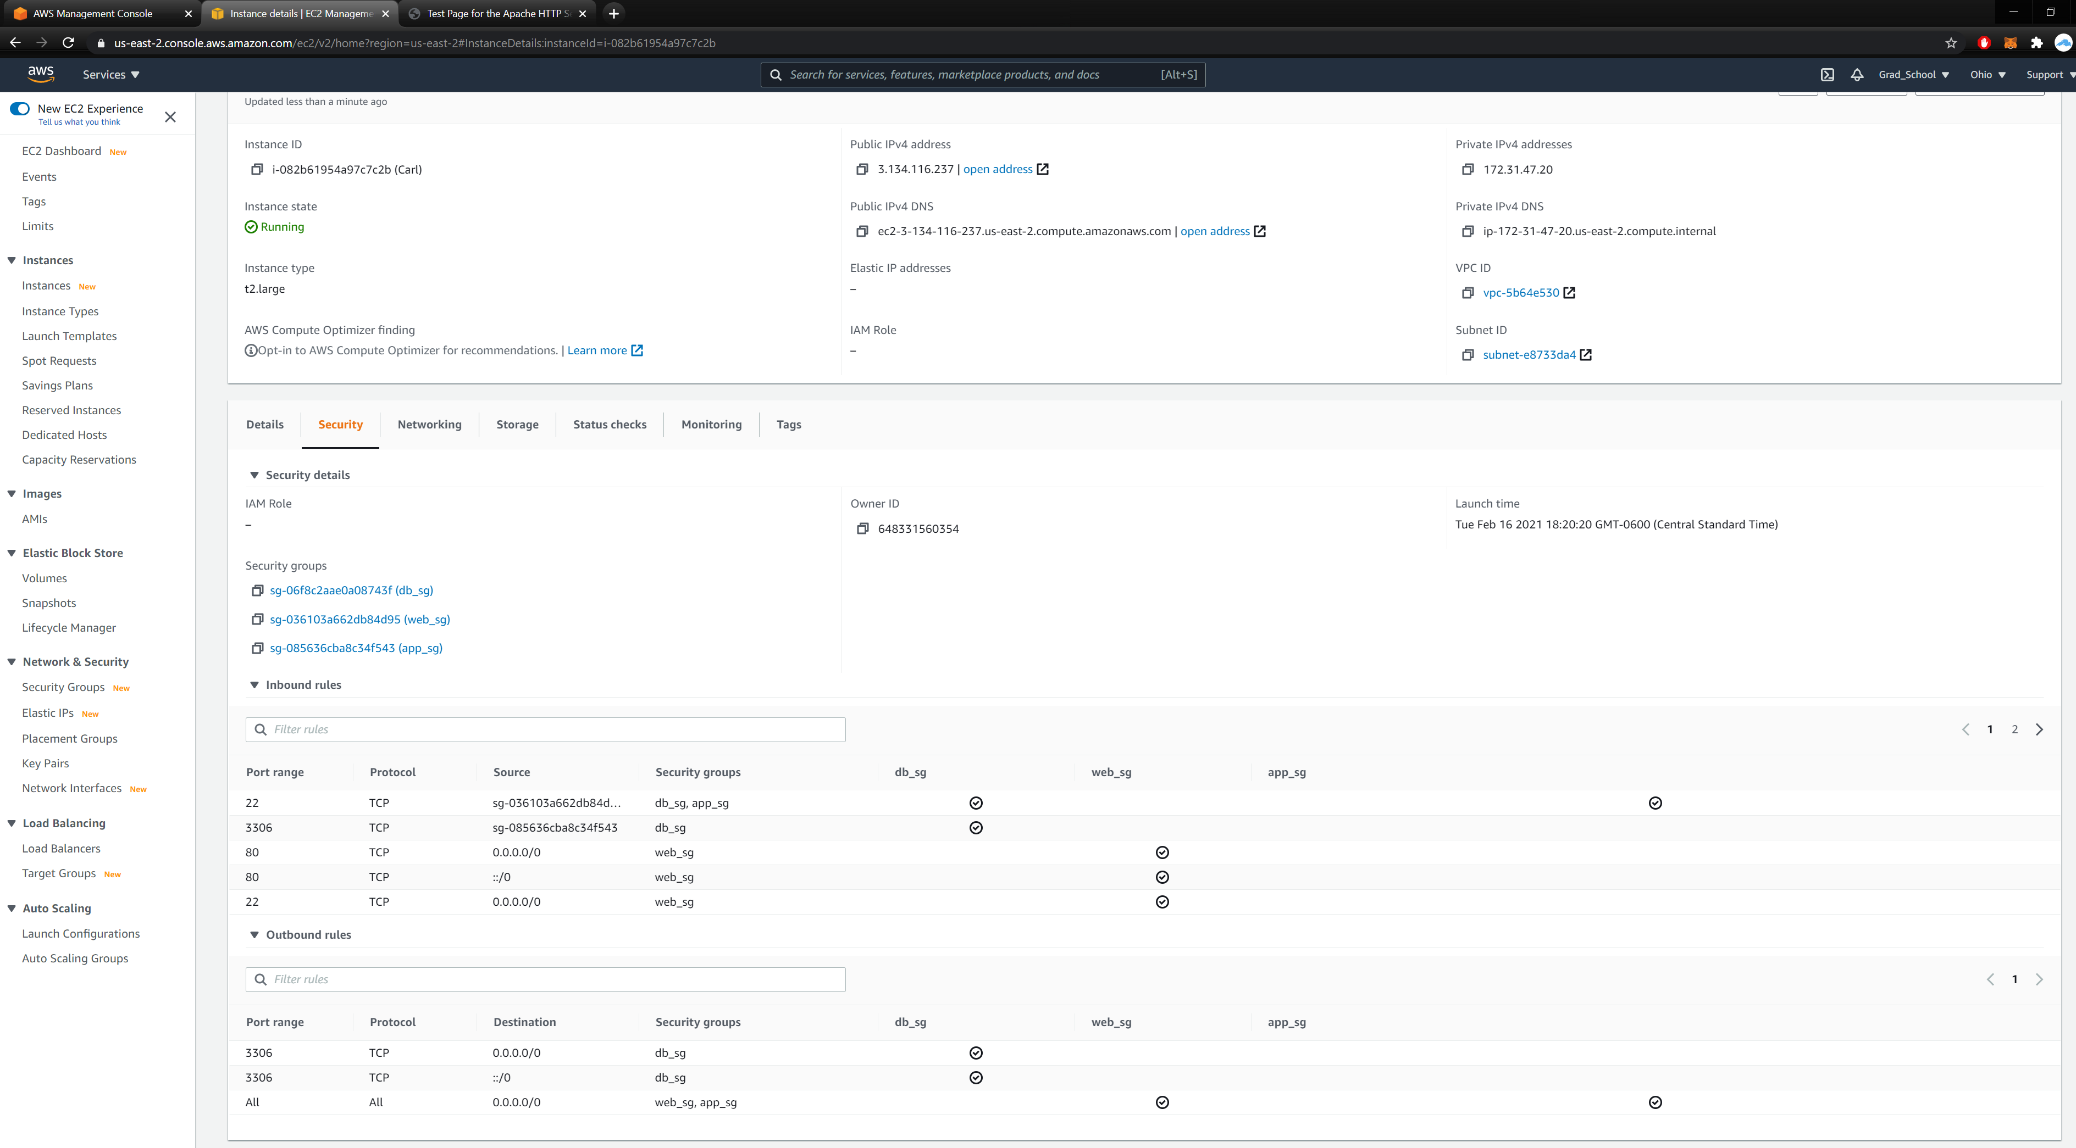

**Lab3D Output**

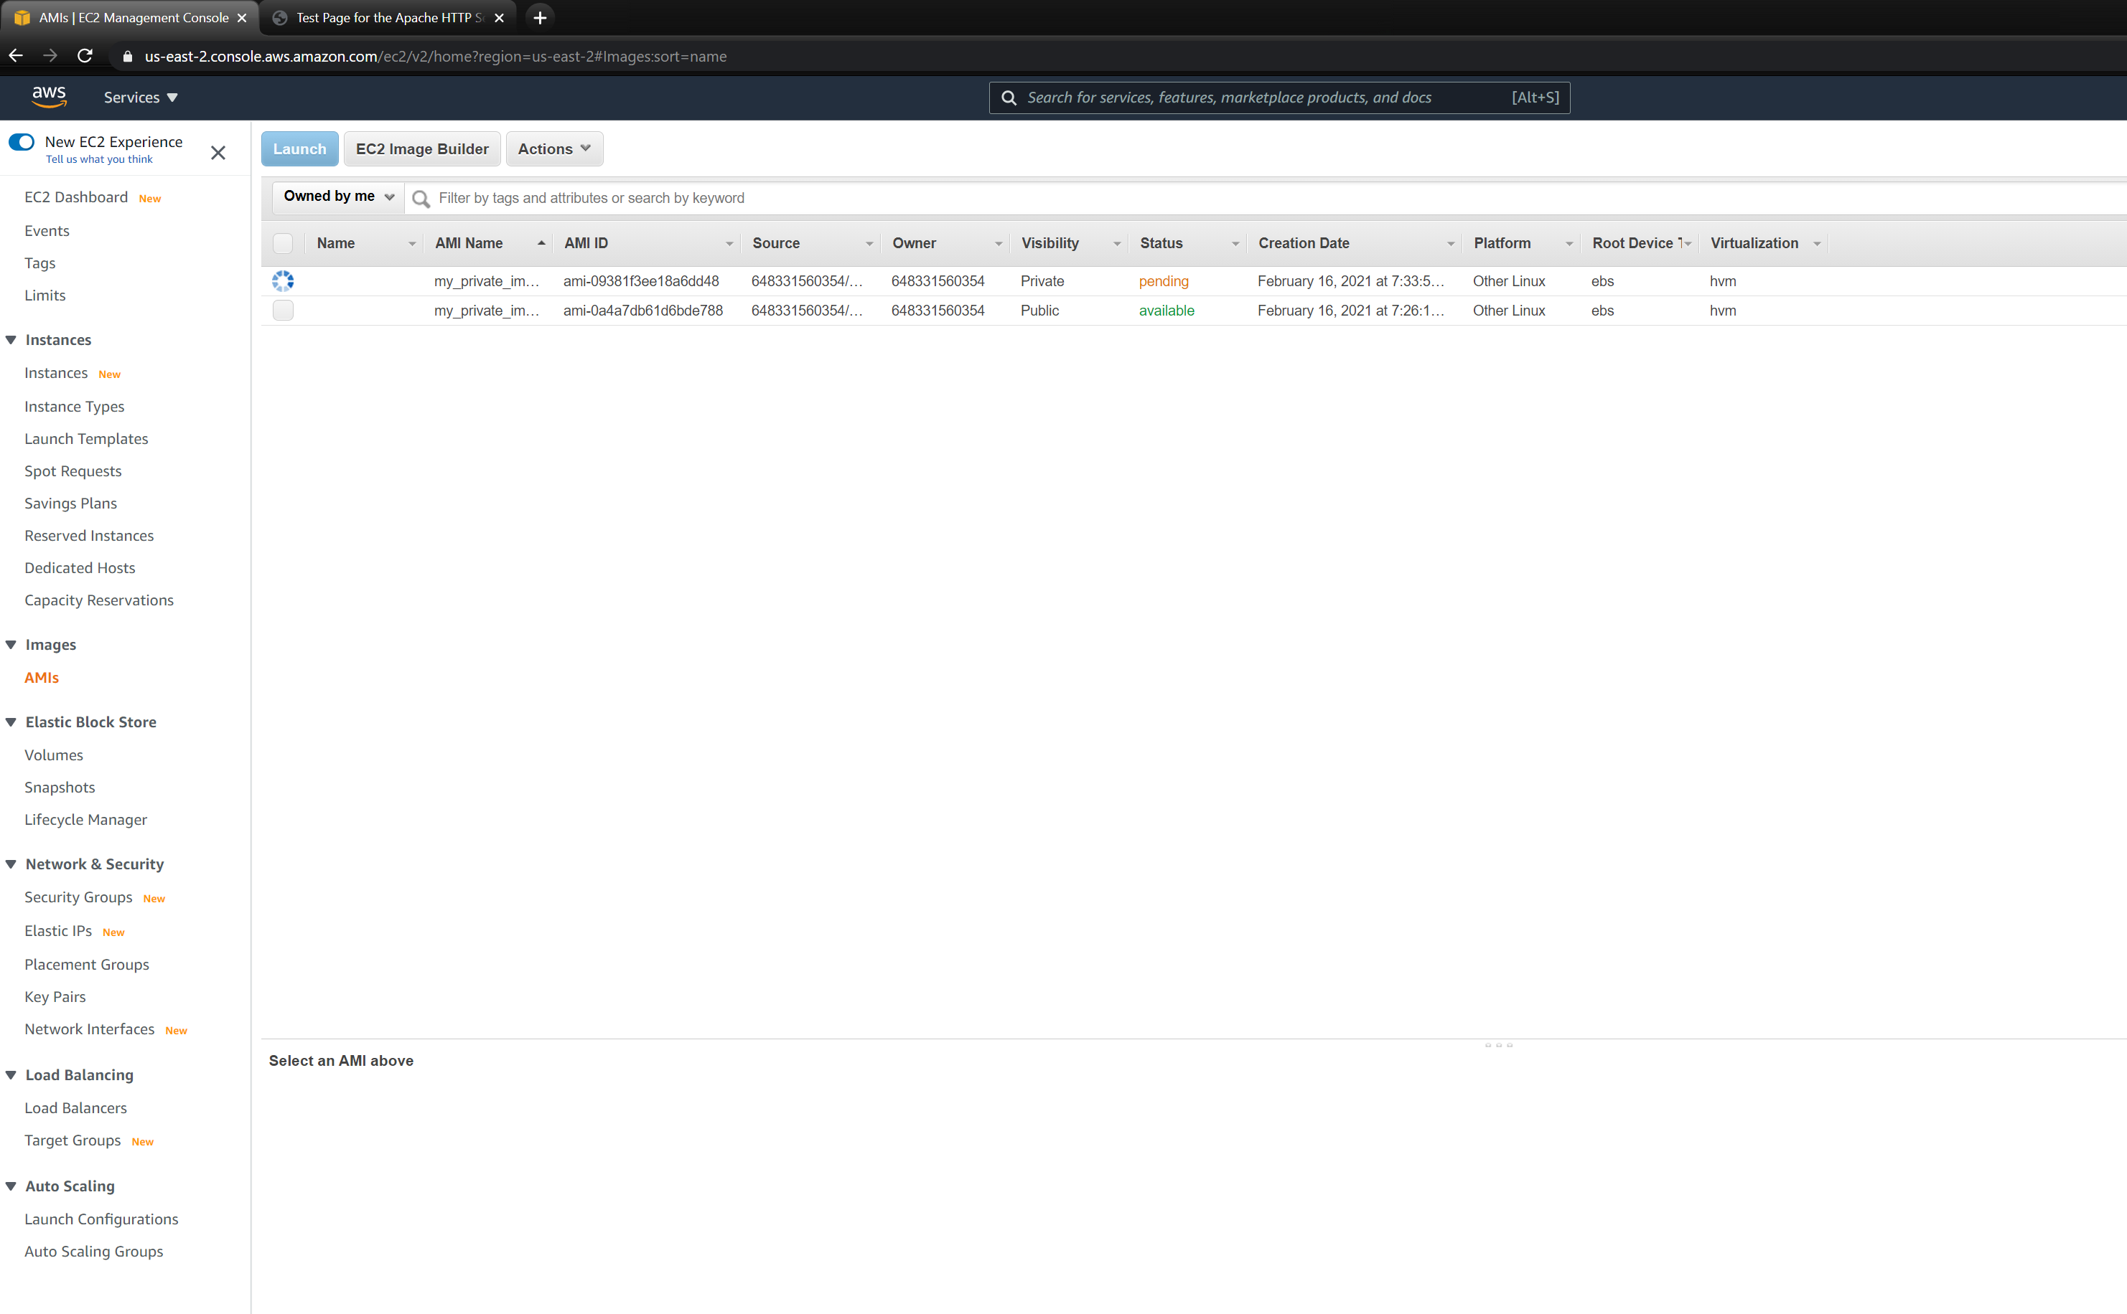

**Lab3E Output**

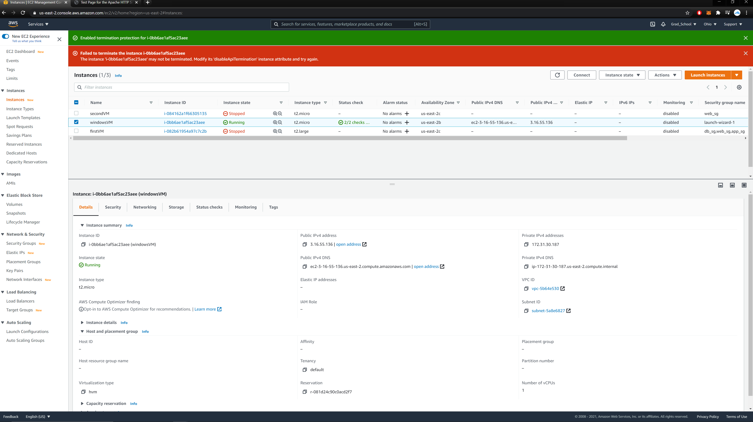

**Lab3F Output**

